**Resume**

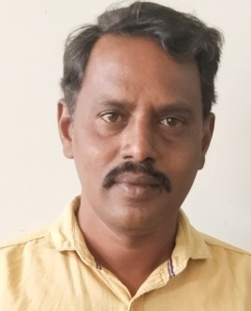

**K.SIDDAPPA Email ID :** [**ksiddappa79@gmail.com**](mailto:ksiddappa79@gmail.com) **Cell 09704432006**

**OBJECTIVE** : To be a part of professionally well established organization, one that will provide a challenging environment to excel my knowledge, skill and potentials that lead me an effective asset to the organization.

**EDUCATIONAL QUALIFICATIONS**

|  |  |  |  |  |
| --- | --- | --- | --- | --- |
| **S NO** | **Name to the Examination** | **Board/University** | **Year of passing** | **Percentage** |
| 1 | SSC | Board of Secondary School Education. Hyderabad | 1995 | 64 |
| 2 | MPC | Board of Intermediate, A.P. Hyderabad | 1997 | 49 |
| 3 | Degree (B.SC)[MPC] | Govt., Degree college Kalyandurgam | 2000 | 50 |
| 4 | B.Ed., | Jnana Bharathi College of Education, KLD | 2007 | 60 |
| 5 | M.SC (Chemistry) | ANU, Guntur | 2009 | 57 |
| 6 | B.P.Ed., | Bharathulla University, Madhya Pradesh | 2014 | 59 |

**EXPERENCE :**

Worked as Lecturer in Chemistry in K.T.S. Govt Degree College, Rayadurg for 3,years and now working .

**PERSONAL SKILLS :**

* Comprehensive problem solving ability.
* Organization abilities.
* Ability to cope stress and work pressures.

**PERSONAL PROFILE :**

Full Name : K.SIDDAPPA

Father’s Name : K.SAVARAPPA

Date of Birth : 10-03-1979

Sex : MALE

Marital status : Married

Nationality : INDIAN –HINDU

Caste : BC-B (Kurni)

Languages : Telugu, English, Kannada

Hobbies : Reading news paper and Books

Permanent address : D NO.16-3-319/8, Near Railway Station, Rayadurgam – 515865.

Anantapuramu - (Dist.,)

**DECLARATION**

I hereby declare that the above mentioned information is true up to my knowledge and I bear that responsibility for the correctness of the above details.

**Place :Rayadurg**

**Date :25-02-2025 K.SIDDAPPA**